1. Introduction
The objective of Stage 2 of the Customer Churn Analysis project was to prepare the telecommunications customer dataset for machine learning and perform clustering analysis to identify meaningful customer segments. Data preparation ensures data quality, consistency, and compatibility with analytical models, while clustering helps uncover hidden patterns in customer behaviour that can support retention strategy development.
The analysis was conducted using Python and key data science libraries including Pandas, NumPy, Matplotlib, and Scikit-learn.

2. Data Preparation
Data preparation was performed to ensure the dataset was consistent, machine-learning ready, and suitable for clustering and predictive modeling. This stage focused on validating data quality, transforming categorical attributes, scaling features, and preparing structured datasets for later analysis.
2.1 Initial Data Exploration
The dataset contained customer information related to demographic attributes, service subscriptions, contract types, and churn status. An initial exploratory inspection was performed using Pandas functions such as head(), info(), and describe() to understand data structure and feature types.
Key observations from the initial exploration included:
- Total records: 7043 customers
- Total features: 10
- Target variable: Churn
- Data types included numerical and categorical attributes.
- Variables such as contract type, gender, payment methods, and internet service were categorical in nature.
Understanding data types at this stage helped determine the preprocessing techniques required for machine learning compatibility.

2.2 Missing Data Handling and Data Integrity
A complete check for missing values was conducted across all columns using null-value analysis. The results indicated that:
- No missing data points were present in the dataset.
Because data completeness was confirmed, no imputation techniques were required. This ensured that preprocessing focused purely on transformation rather than correction, preserving data integrity.
Additional validation steps ensured:
- No duplicated rows were identified.
- Feature values remained consistent with expected categories.
- Target variable labels were clearly defined as Yes/No.

2.3 Categorical Encoding
Machine learning algorithms require numeric inputs; therefore, categorical variables were transformed into numerical representations.
The following preprocessing steps were applied:
- The target variable Churn was converted into binary format:
  - Yes → 1
  - No → 0
- Input categorical variables were encoded using one-hot encoding.
One-hot encoding was chosen because:
- It avoids artificial ordinal relationships between categories.
- It preserves interpretability of customer attributes.
- It is suitable for clustering and neural network modeling.
During encoding, multiple new binary features were created (e.g., contract type and internet service categories). Boolean outputs generated by the encoding process were converted into numeric format (0/1) to maintain full compatibility with analytical models.

2.4 Feature Engineering Considerations
Although no new engineered features were introduced at this stage, careful transformation of existing variables ensured that:
- Customer demographic characteristics,
- Service subscription preferences,
- and billing attributes
were all represented numerically and could contribute to distance-based clustering.
The preprocessing pipeline ensured consistent feature representation across all samples.

2.5 Feature Scaling and Normalization
Feature scaling was performed using StandardScaler from Scikit-learn.
This step was critical because K-Means clustering relies on Euclidean distance calculations. Without scaling, features with larger numeric ranges (e.g., tenure or monthly charges) would dominate clustering behaviour and bias results.
Standardization transformed each feature to:
- Mean ≈ 0
- Standard deviation ≈ 1
Benefits of scaling included:
- Balanced feature contribution
- Improved convergence of clustering algorithms
- Improved stability for later ANN modeling

2.6 Train-Test Data Splitting
The preprocessed dataset was divided into training and testing subsets to support reliable model development and validation.
Configuration used:
- Training set: 80%
- Testing set: 20%
- Stratified sampling based on churn
Stratification ensured that churn distribution remained consistent between datasets, reducing sampling bias and improving the reliability of future predictive modeling in Stage 3.
The resulting outputs included:
- X_train and X_test feature sets
- y_train and y_test target labels
- Scaled versions of training and testing features

2.7 Outcome of Data Preparation
By the end of this stage:
- All features were numerical and model-ready.
- Data was standardized for clustering analysis.
- Structured training and testing datasets were created.
- The dataset was fully prepared for unsupervised segmentation using K-Means clustering.
3. Clustering Analysis
Clustering analysis was conducted to identify natural groupings within the customer base based on behavioural and service-related attributes. By segmenting customers into distinct groups, the analysis aimed to reveal patterns associated with customer characteristics and potential churn behaviour. K-Means clustering was selected due to its efficiency, interpretability, and suitability for structured numerical data.
3.1 Determining the Optimal Number of Clusters
To identify the appropriate number of customer segments, the Elbow Method was applied. Multiple K-Means models were trained with varying cluster numbers, and the Within-Cluster Sum of Squares (WCSS) was examined.
The resulting curve showed a noticeable decrease in inertia up to a certain point, after which improvements became progressively smaller. This change in slope indicated the point of diminishing returns.
The elbow was identified at K = 5, suggesting that five clusters offered a balance between segmentation detail and model simplicity.
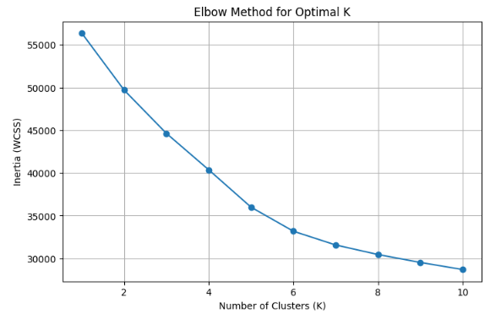
Figure 1: Elbow Method showing the optimal number of clusters selected at K = 5.

3.2 K-Means Model Training
After selecting the optimal number of clusters, a K-Means model was trained using the scaled training dataset. Scaling ensured that all features contributed equally to distance calculations, preventing variables with larger ranges from dominating cluster formation.
Each customer record was assigned a cluster label representing membership within one of five customer segments. These labels enabled further analysis of behavioural patterns across groups and laid the foundation for interpreting customer profiles.

3.3 Cluster Visualization Using PCA
Since the dataset contains multiple features, direct visualisation is not possible in high-dimensional space. Therefore, Principal Component Analysis (PCA) was used to reduce the data to two dimensions while retaining the majority of variance.
The PCA projection provided a visual representation of the clusters, allowing inspection of cluster separation and overlap. The visualization indicates that customer groups form distinct segments, supporting the suitability of the clustering approach.
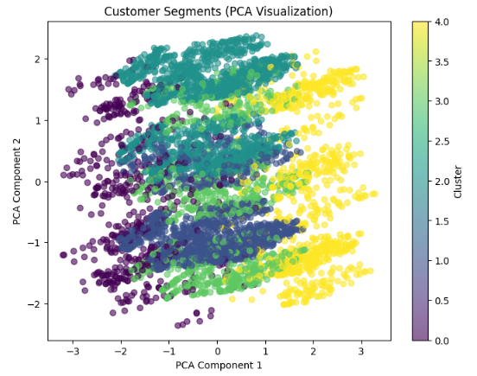
Figure 2: PCA-based visualization of customer clusters generated by K-Means.

3.4 Cluster Characteristics and Observations
Cluster-level analysis was conducted by calculating the average feature values and churn rates for each segment. This helped translate numerical clusters into meaningful customer groups.
Key observations include:
- Customers were grouped into segments exhibiting different tenure lengths and spending patterns.
- Some clusters showed characteristics associated with higher churn risk, particularly shorter tenure and higher monthly charges.
- Other clusters appeared more stable, consisting of long-tenure customers with lower churn rates.
These differences suggest that customer behaviour is not homogeneous and that retention strategies should be tailored to individual segments rather than applied uniformly across the customer base.
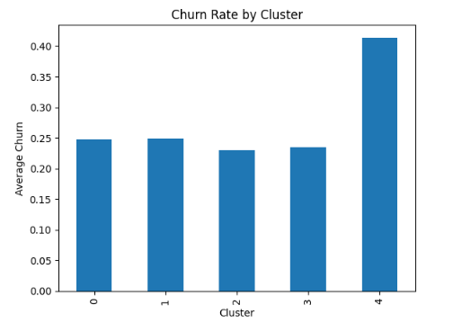
3.5 Outcome of Clustering Analysis
The clustering process successfully segmented customers into five meaningful groups. The results demonstrate that customer behaviour varies across multiple dimensions, including subscription duration and billing patterns. These insights provide a strong analytical foundation for targeted business strategies and for the predictive modeling phase in Stage 3.

4. Cluster Insights and Business Interpretation
The purpose of this section is to translate the clustering results into meaningful business insights that can support customer retention strategies. By analysing average feature values and churn patterns within each cluster, distinct customer profiles were identified.
Cluster analysis showed that customers differ significantly across factors such as tenure, service usage, and monthly charges. These differences indicate that churn risk is not uniform and that specific customer segments require targeted attention.
4.1 Cluster-Level Behavioural Patterns
Analysis of cluster summaries revealed clear variations between customer groups. Some clusters consisted of customers with longer subscription durations and more stable behavioural patterns, while others displayed characteristics commonly associated with higher churn risk.
General observations include:
- Customers with shorter tenure tended to appear in higher-risk clusters.
- Higher monthly charges were frequently associated with increased churn likelihood.
- Long-term contract customers were generally concentrated in more stable clusters.
These patterns suggest that service cost, contract structure, and customer lifecycle stage strongly influence segmentation outcomes.

4.2 Churn Risk Across Customer Segments
Churn rate comparisons across clusters provided additional insight into which customer segments require proactive intervention.
The analysis demonstrated that:
- Certain clusters displayed noticeably higher average churn rates.
- High-risk clusters often represented newer customers with limited tenure.
- Lower-risk clusters included long-term subscribers with more consistent service usage.
This highlights the importance of early-stage customer engagement and value reinforcement during the initial subscription period.
(If included, insert optional visual here)
Optional visual:
- Churn Rate by Cluster bar chart
Caption:
Figure 3: Comparison of churn rates across customer clusters.

4.3 Business Interpretation of Customer Segments
The clustering results suggest that customers can be viewed as distinct behavioural groups rather than a single homogeneous population. From a business perspective, this enables segmentation-driven decision making.
Examples of strategic interpretation include:
- High-churn clusters may require retention campaigns, onboarding support, or promotional offers.
- Medium-risk clusters may benefit from personalised service recommendations to increase engagement.
- Stable clusters represent loyal customers who can be targeted for long-term loyalty programs or upselling opportunities.
By identifying these groups early, the organisation can allocate resources more effectively and improve overall customer lifetime value.

4.4 Strategic Value of Segmentation
Customer segmentation provides a data-driven foundation for retention strategy development. Instead of applying uniform marketing or service policies, telecommunications companies can tailor interventions to specific behavioural profiles.
Key outcomes from the segmentation process include:
- Improved understanding of customer diversity.
- Identification of high-risk customer groups.
- Clear analytical input for future predictive modeling.
These insights directly support the objectives of the project, preparing the dataset for advanced churn prediction in Stage 3.
5. Key Findings
The data preparation and clustering analysis produced several important insights regarding customer behaviour and segmentation patterns. The preprocessing pipeline successfully transformed the raw dataset into a structured, machine-learning-ready format, enabling reliable clustering analysis.
Key findings from Stage 2 include:
- The dataset required minimal cleaning, allowing focus on transformation and modeling readiness.
- Feature scaling significantly improved compatibility with distance-based clustering algorithms.
- The Elbow Method identified five meaningful customer segments.
- Clustering revealed clear behavioural differences between customer groups.
- Churn behaviour varied across clusters, indicating that customer risk levels differ based on subscription and usage patterns.
Overall, the analysis demonstrates that customer segmentation can reveal actionable insights that are not visible when analysing the customer base as a single group.

6. Limitations and Challenges
While the clustering analysis produced meaningful segmentation, several limitations should be acknowledged.
First, K-Means clustering is an unsupervised technique and does not directly optimise for churn prediction. As a result, cluster formation is based on feature similarity rather than churn outcomes.
Second, PCA visualisation reduces multiple dimensions into two components, which simplifies interpretation but may not fully represent complex relationships within the dataset.
Additionally:
- The analysis used only available features within the dataset.
- External factors such as customer satisfaction or service quality metrics were not included.
- Cluster interpretation relies on aggregate averages, which may not fully capture individual customer behaviour.
These limitations highlight opportunities for improvement in future stages through advanced modeling and feature expansion.

7. Conclusion
Stage 2 of the Customer Churn Analysis project successfully prepared the telecommunications dataset and applied clustering techniques to identify distinct customer segments. Data preprocessing ensured consistency, numerical compatibility, and scaling across features, creating a robust foundation for analysis.
The clustering process identified five meaningful customer groups, revealing variations in behavioural patterns, spending characteristics, and churn tendencies. These insights demonstrate that customer populations are diverse and require targeted analytical approaches rather than uniform strategies.
The outcomes of this stage provide valuable input for Stage 3, where predictive modeling techniques will be used to forecast customer churn and support the development of data-driven retention strategies.

